Online school portal
https://students.jmhs.com/
Username: Carriegilles@ymail.com
Password: 133Pinson

Log in
Click on Algebra ll: Part 1
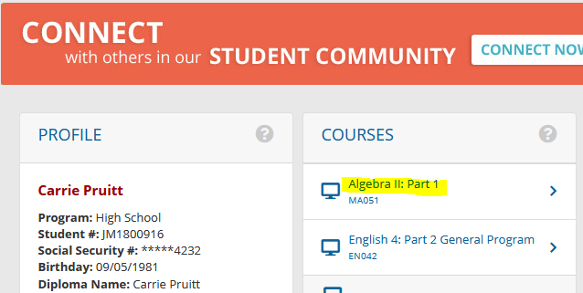

Assessments
- Quizzes
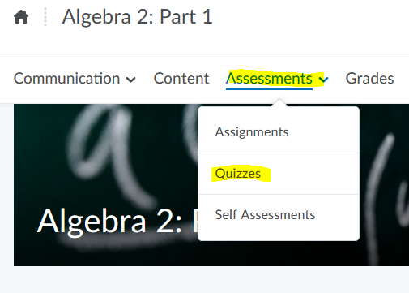

All 4 quizzes will populate
- Click on each one and answer all questions

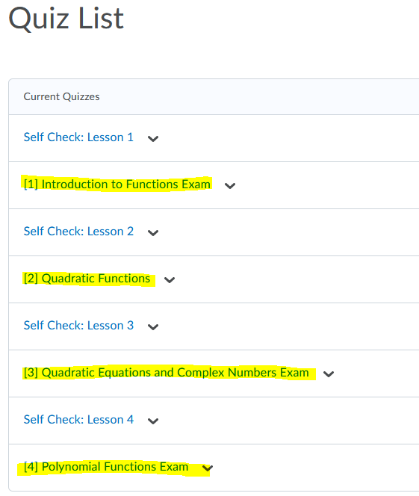

If you need any help,

Click on the content tab next to assessments and it will give you further information on the course

ONLY THE 4 QUIZZES HIGHLIGHTED IN YELLOW ABOVE ARE GRADED. YOU CAN DO THE SELF CHECK IF YOU NEED PRACTICE, BUT THEY ARE NOT COUNTED FOR AS A GRADE.

YOU ONLY GET 2 TRIES AT EACH QUIZ

